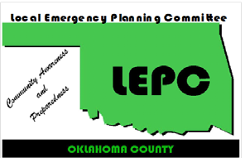
Oklahoma County LEPC
Meeting Agenda
February 14th, 2018 2:00 PM

Location: Oklahoma Department of Environmental Quality
707 N. Robinson Ave., Oklahoma City, OK
Agenda Topics | Presenter
Welcome Members and Guests | T. Menzer
Approval of Minutes from last Meeting | T. Menzer
Treasurer’s Report | R. Dallen
Public Comments -  Any Oklahoma County citizen may address the Committee on their concerns. | All
Spill Notifications | All
Old Business  - Confirmation of Johnny Wingate to Information Officer position.  - Training Opportunities  - DEQ Grants  - Sponsorship for PHMSA Class | T. Menzer
New Business –  This item is listed to provide the opportunity for Committee action on items that may arise within 24 hours prior to this meeting, and therefore qualify as new business under Oklahoma’s OPEN MEETING LAW. | All
Program: Tier II Reporting Refresher
The next meeting will be held on May 9th, 2018
www.okcountylepc.org
320 Robert S. Kerr, Suite 101, Oklahoma City, OK 73102

T.J. Menzer, Chair, Edmond EM @ 359-4564 24-hr Notification - @ 739-1386
Mike Bower, Vice-Chair, Midwest City EM @ 739-1386 David Barnes, (Co Em Mgr) @ 713-1369
Brook Pintens, Secretary, Edmond EM @ 359-4564 Frank Barnes, (OKC Emergency Manager) @ 405-605-8981 Rebecca Dallen, Treasurer, OKC SWQ @ 297-1527 Jeremy Robbins, Info Coor, Midwest City FD @ 739-1348

To enhance the protection of the community and environment from hazardous materials incidents through planning, preparation and communication between citizens, business and government.

