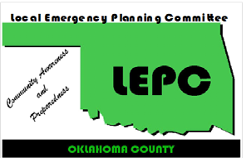
Oklahoma County LEPC
Meeting Agenda
Nov. 14, 2018 2:00 PM

Location: Trilink Restoration
3300 N. Santa Fe. Oklahoma City, OK 73118
Agenda Topics | Presenter
Welcome Members and Guests | T. Menzer
Approval of Minutes from last Meeting | T. Menzer
Treasurer’s Report | R. Dallen
Round Table Discussion -  Discussion of EM and industry topics. | All
Spill Notifications | All
Old Business  - Training Opportunities  - Stormwater Workshop follow up (Oct. 30 -31)  - 2019 Meeting dates | T. Menzer
New Business –  This item is listed to provide the opportunity for Committee action on items that may arise within 24 hours prior to this meeting, and therefore qualify as new business under Oklahoma’s OPEN MEETING LAW. | All
Program: Trilink Tour
The next meeting is TBD
www.okcountylepc.org
320 Robert S. Kerr, Suite 101, Oklahoma City, OK 73102

T.J. Menzer, Chair, Edmond EM @ 359-4564 24-hr Notification - @ 739-1386
Mike Bower, Vice-Chair, Midwest City EM @ 739-1386 David Barnes, (Co Em Mgr) @ 713-1369
Brook Pintens, Secretary, Edmond EM @ 359-4564 Frank Barnes, (OKC Emergency Manager) @ 405-605-8981 Rebecca Dallen, Treasurer, OKC SWQ @ 297-1527 Johnny Wingate, Info Officer, OKC County Health Dept. @ 405-425-4472

To enhance the protection of the community and environment from hazardous materials incidents through planning, preparation and communication between citizens, business and government.

